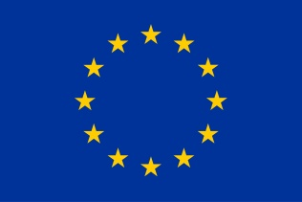  HORIZON 2020 | HORIZON 2020 RESEARCH AND INNOVATION FRAMEWORK PROGRAMME OF THE EUROPEAN ATOMIC ENERGY COMMUNITY

Nuclear Fission and Radiation Protection 2018 (NFRP-2018-4)

Project acronym: SANDA

Project full title: Solving Challenges in Nuclear Data for the Safety of European Nuclear facilities

Grant Agreement no.: H2020 Grant Agreement number: 847552

Workpackages: WP1, WP2

Identification N°: MS29

Type of document: Milestones

Title of milestone: Decision on targets to be manufactured

Dissemination Level: PU

Reference:

Status: {Achived / Canceled}

Actual Dalivery date: 28 February 2021

Comments:

 | Name | Partner | Date | Signature
Prepared by: | A. Bxxxx | 1 | 05-08-2020 | <If at all possible use electronic signature>
WP leader: | E. Bxxxx | 1 | 05-08-2020 | <If at all possible use electronic signature>
IP Co-ordinator: | E. González | 1 | 05-08-2020

